**PHP Activity**

**Learning outcomes:**

1. Understand the importance of version control, testing, and automated processes in software development

Continuous Delivery

* 1. Configuration Management
  2. Webhook from Version Control System
  3. Static Code Analysis
  4. Unit Testing
  5. Integration Testing
  6. Staging

1. Successfully commit a code change through the Continuous Delivery Educational Pipeline (CDEP).
2. Navigate through and customize a Continuous Delivery system using the Visual Continuous Delivery Educational Pipeline (V-CDEP) application.

**Prerequisites:**

1. Create a Github account, if you don’t have one already.
2. Submit your Github username to the instructor.
3. Have Git installed on the machine you are using.
4. Have downloaded the V-CDEP application from [VCDEP.com/download](http://vcdep.com/download).

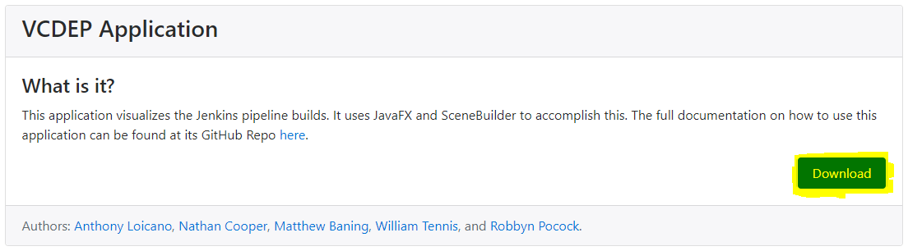

## **NOTE:** All **information** that you must replace inside of a command such as cloning a git repository will be surrounded by angle brackets

## (Example: **git clone <your_repo>** means replace <your_repo> with the url of your repository).

## **NOTE:** All **commands** that you will run are surrounded with single quotes

## (Example: **‘cd </path/to/your/repo>’**).

## **NOTE:** All **links and information** are surrounded with double quotes

## (Example: navigate your browser to **“<jenkins_ip_address>”**).

## **WARNING:** Improper use of strings provided within double quotations for links and information as well as commands provided within single quotations, could possibly create unintended and undesired errors.

**Setup:**

**In this section we will clone down your git repository onto your local machine, set your browser to view the Jenkins server, and run the V-CDEP application.**

*It might be helpful to annotate each specific address below:*

Your_repository_url:_____________________________________________________

Your_repo_name:_______________________________________________________

Jenkins_ip_address:_____________________________________________________

**Setup part I: The Jenkins Pipeline**

1. Open up the git bash command line interface and navigate using ‘cd’ or on windows ‘dir’ to the local destination of your repo. Example: **‘cd <path/to/directory/>’**.
2. Perform the git clone command:
   1. **‘git clone <your_repository_url>’**. You can find your repository url from the Github website by clicking the green ‘Clone or download’ button when on the page for your repository.
3. Change directory into the repo using ‘cd’ or on windows ‘dir’.
4. Example: **‘cd <your_repo_name>’**.
5. Change the branch of the git repo from master to feature by performing the command **‘git checkout feature’**
6. Point your browser to **“<jenkins_ip_address>”** and select the Jenkins’ job **“jenkins_pipeline”**
7. Open another tab in your browser and point it to **“http://<jenkins_ip_address>/staging/php/<your_repo_name>/index/ ”**. You will be brought to a 404 Not Found page. Do not freak out! This is a part of the initial setup.

**Setup part II: The V-CDEP application**

1. Navigate via your file explorer to where you downloaded the V-CDEP application from the prerequisites. Right click the V-CDEP.zip file and click “Extract All...”.

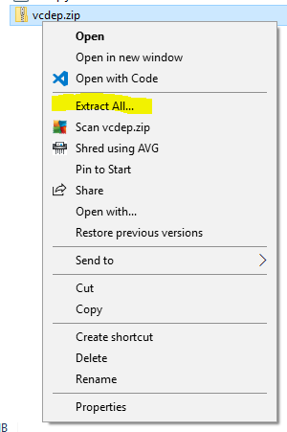

* 1. This will extract the .jar file to the directory you specify.

1. Double click the V-CDEP.jar file that was extracted

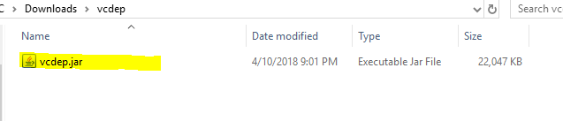

* 1. This will run and open the V-CDEP application.
  2. 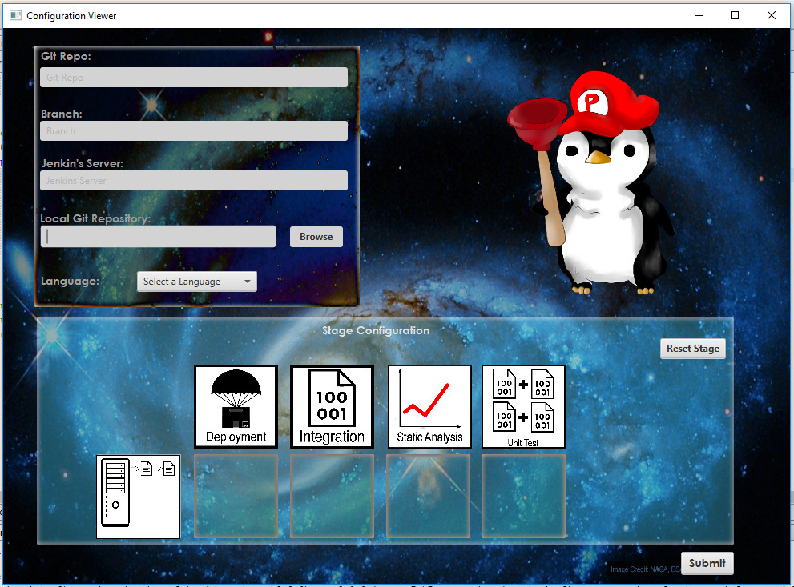

1. Celebrate, you finished the setup!

*********************************************SETUP COMPLETE***************************************

**Assignment:**

This assignment is broken into **two** parts. The first portion consists of initial testing, modification checks, and pipeline failure, and will be completed in the first class period. The second portion consists of adding extra features (and their respective tests), and will be completed in the second class period.

************************************************PART ONE**********************************************

1. **Initial Testing and Checks:** You will be making a very small change to your github project and running that change through the pipeline and the V-CDEP application to make sure everything is working correctly.

**Configuring the V-CDEP Application:**

1. Make sure the V-CDEP application is currently open and on the Configuration Viewer page.
2. Input the name of your repository in the first field. Example: If your repository is named “student_1_php_activity” you would input **“student_1_php_activity”** into that field. **(MUST BE LOWER CASE)**
3. For the branch you must use **“feature”**.
4. For the Jenkins server you must place the Jenkins IP address which will be given to you by your professor.
5. To fill in the Local Git Repository field you will click the browse button.

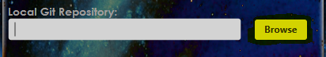

1. This will open the File Directory picker. You will navigate to where your git repository is stored on your machine and then hit the “Select Folder” button.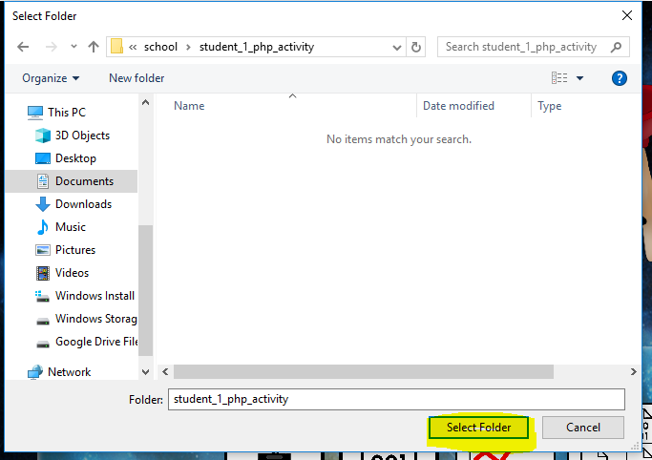
2. Next Select PHP as your language from the list of choices in the combobox.
3. Your Configuration Viewer should look similar to the following

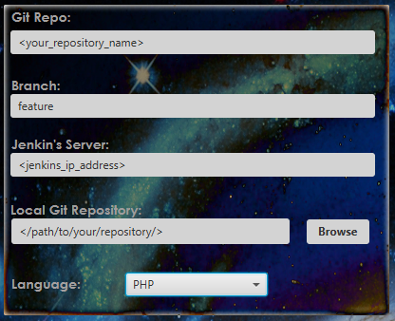

1. Now that you have completed configuration you will select your stages using the drag and drop functionality built into the V-CDEP application.
2. The stages you **must select** ***for this activity*** are “Static Analysis, Unit Test, Integration, and Deployment” ***in that order.*** Shuffling this order is allowed, but for the purposes of this activity (and classroom time constraints) please use this ordering.

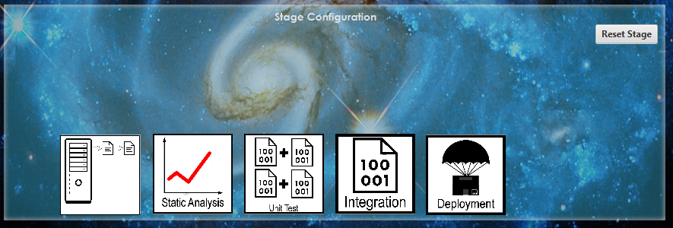

1. This is what your Stage Configuration section should look like.
2. Once you have performed the previous steps, hit the submit button!

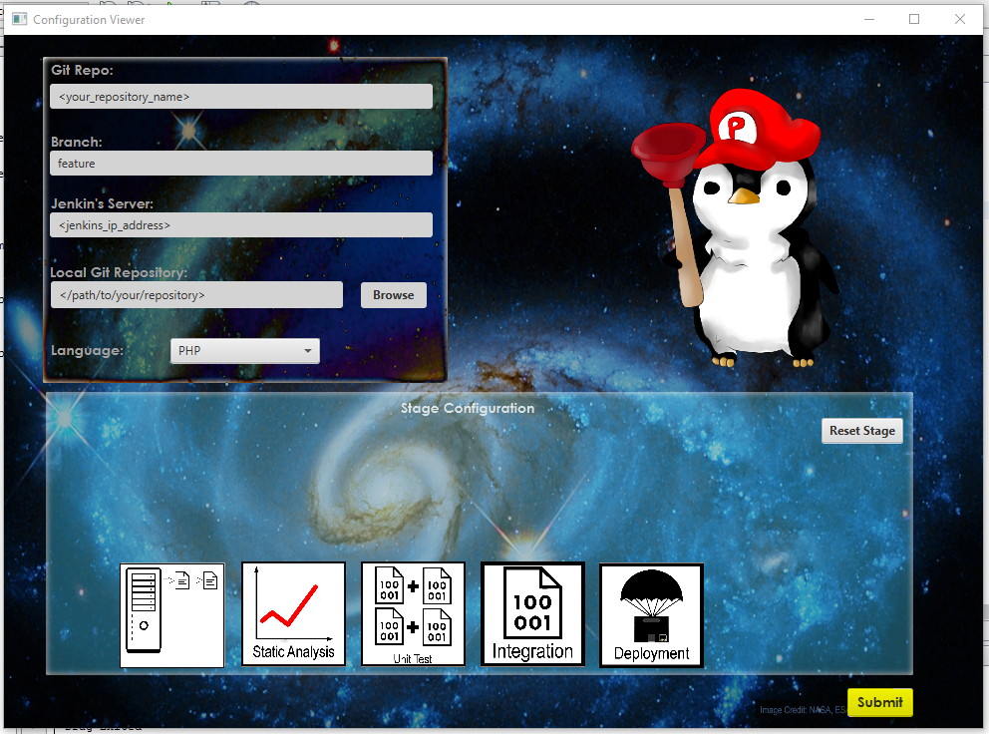

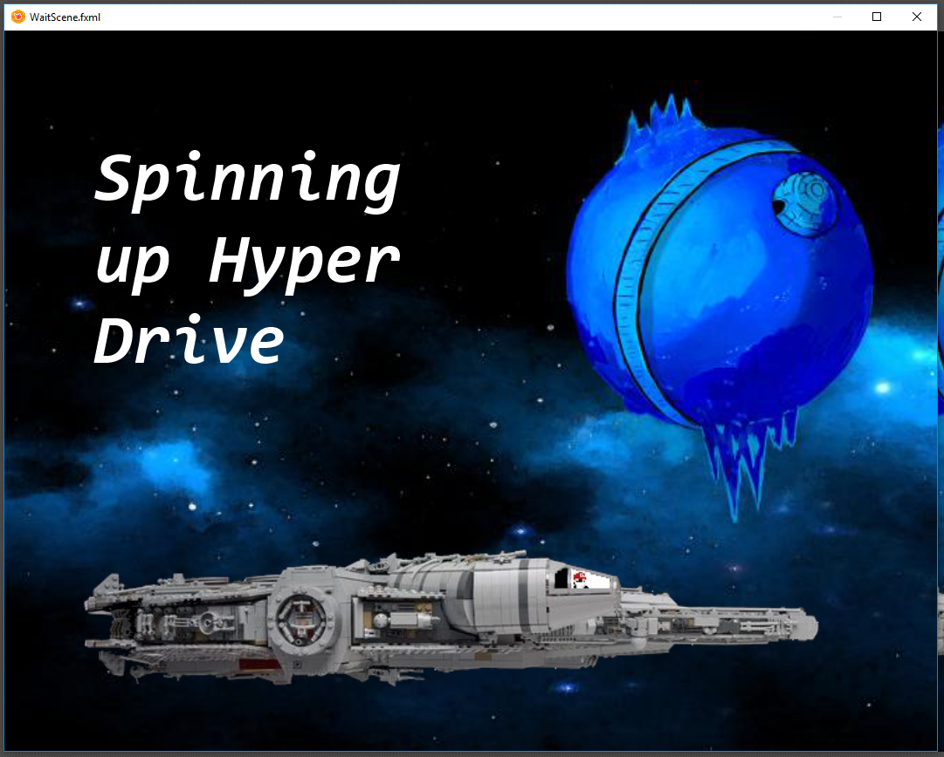

1. If everything was inputted correctly and prerequisites were met, you should see the Wait Scene.
2. **While waiting, continue on with the rest of the activity.**

**Checking the V-CDEP system:**

1. Navigate to where your git repository is stored on your local machine.
2. Enter the **“index”** folder and open the file named **“index.php”** with your favorite text editor.

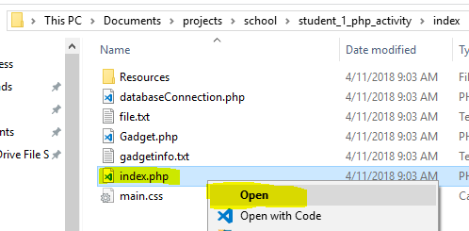

1. Inside the **“index.php”** file, change the information which lies between the two header tags to anything you want. Example: to have the string “V-CDEP is a continuous delivery tool” be displayed as the header you would change the information between the two header tags to **“<header id=”header”>V-CDEP is awesome</header>”.**

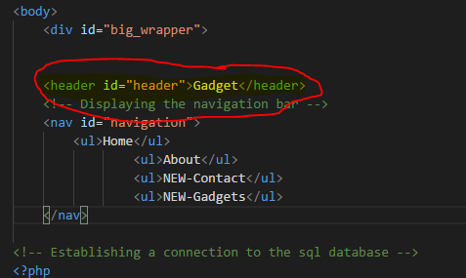

1. Save the changes, then open a terminal in the repository on your local machine (right-click in the folder in the file explorer) and perform the following commands:
2. **‘git add -A’** this will have git start tracking any new files like the config.json file that the V-CDEP application created and also make sure all of the modifications you just made in the index.php are saved.
3. **‘git commit -m “<your_commit_message”’** this will commit all the changes with a message that represents what types of changes you did.
4. **‘git push origin feature’** this will push the changes from your local machine to the remote repository stored in GitHub. You will most likely have to input your user credentials for GitHub.
5. Return to the V-CDEP application which should still be on the Wait Scene and also bring up your browser where you should have the two tabs that have the **Jenkins main page** and the **404 Not Found page**.
6. On the Jenkins main page, you should see your build starting to run.

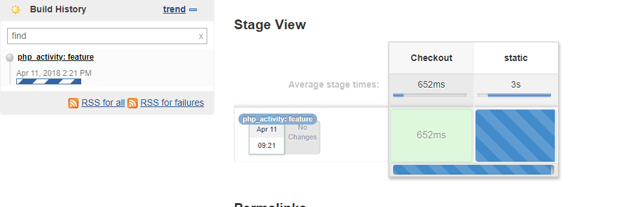

1. Once all stages have finished you should see the pipeline complete.

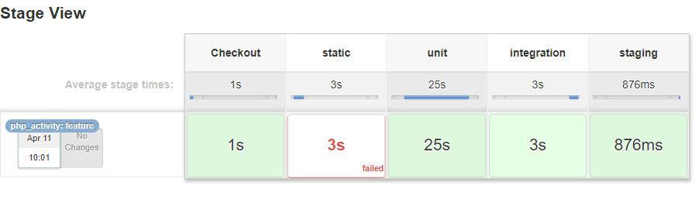

1. All stages completed in above example!
2. ***If you do not see this, contact your instructor or one of the assistants to help you.***
3. Bring up the V-CDEP application, which should have left the Wait Scene and advanced to the Pipeline Scene.

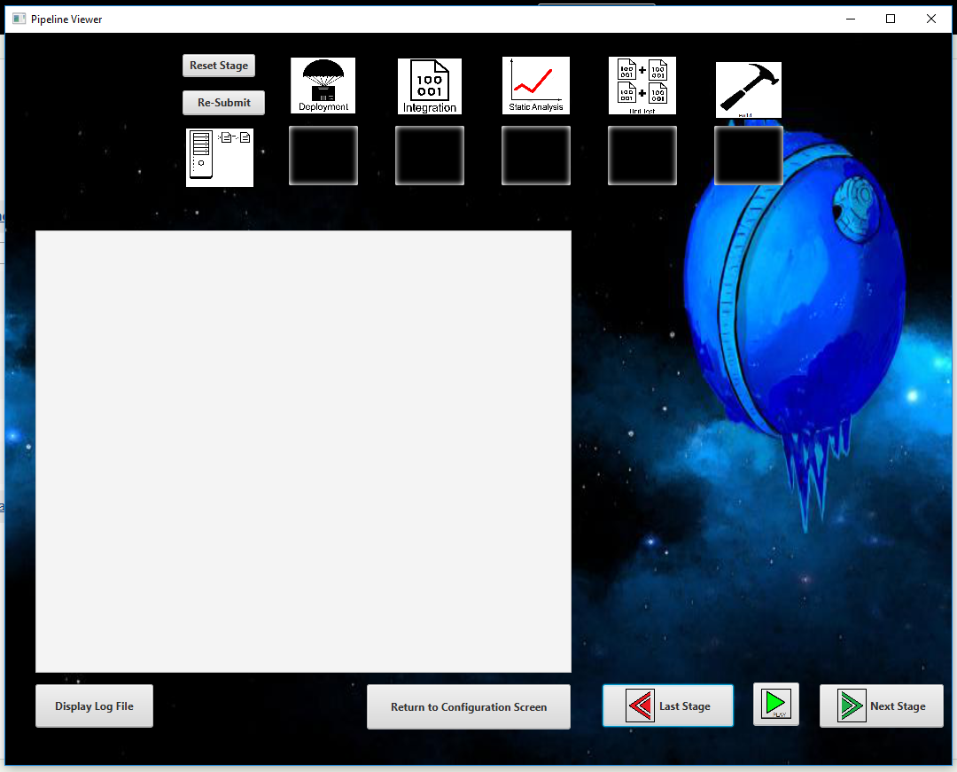

1. The Pipeline Scene
2. Hit the **play** button to start the V-CDEP application’s animations and scripts.
   * + - 1. 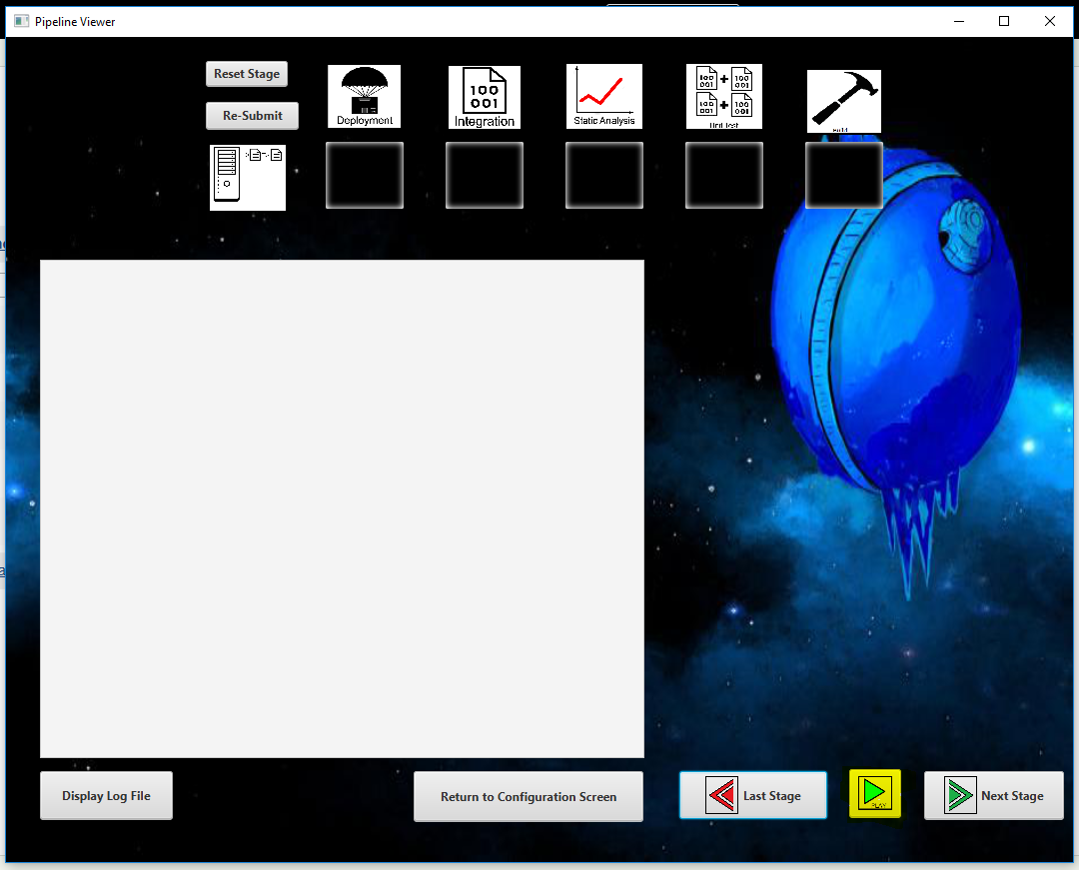
3. The Play button highlighted

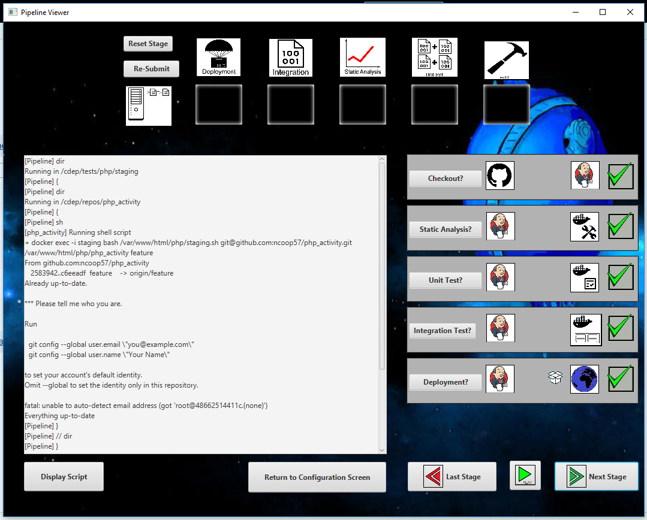

1. You can use the “Display Log File / Display Script” to toggle between seeing the log file and the script for each of the stages.
2. You can use the **navigation buttons** to go to the next stage or previous stage instead of waiting for the animations to play all the way through.

**Viewing the changes made on your website**

1. Reload the browser that was pointed to **“http://<jenkins_ip_address>/staging/php/<your_repo_name>/index/ ”**.

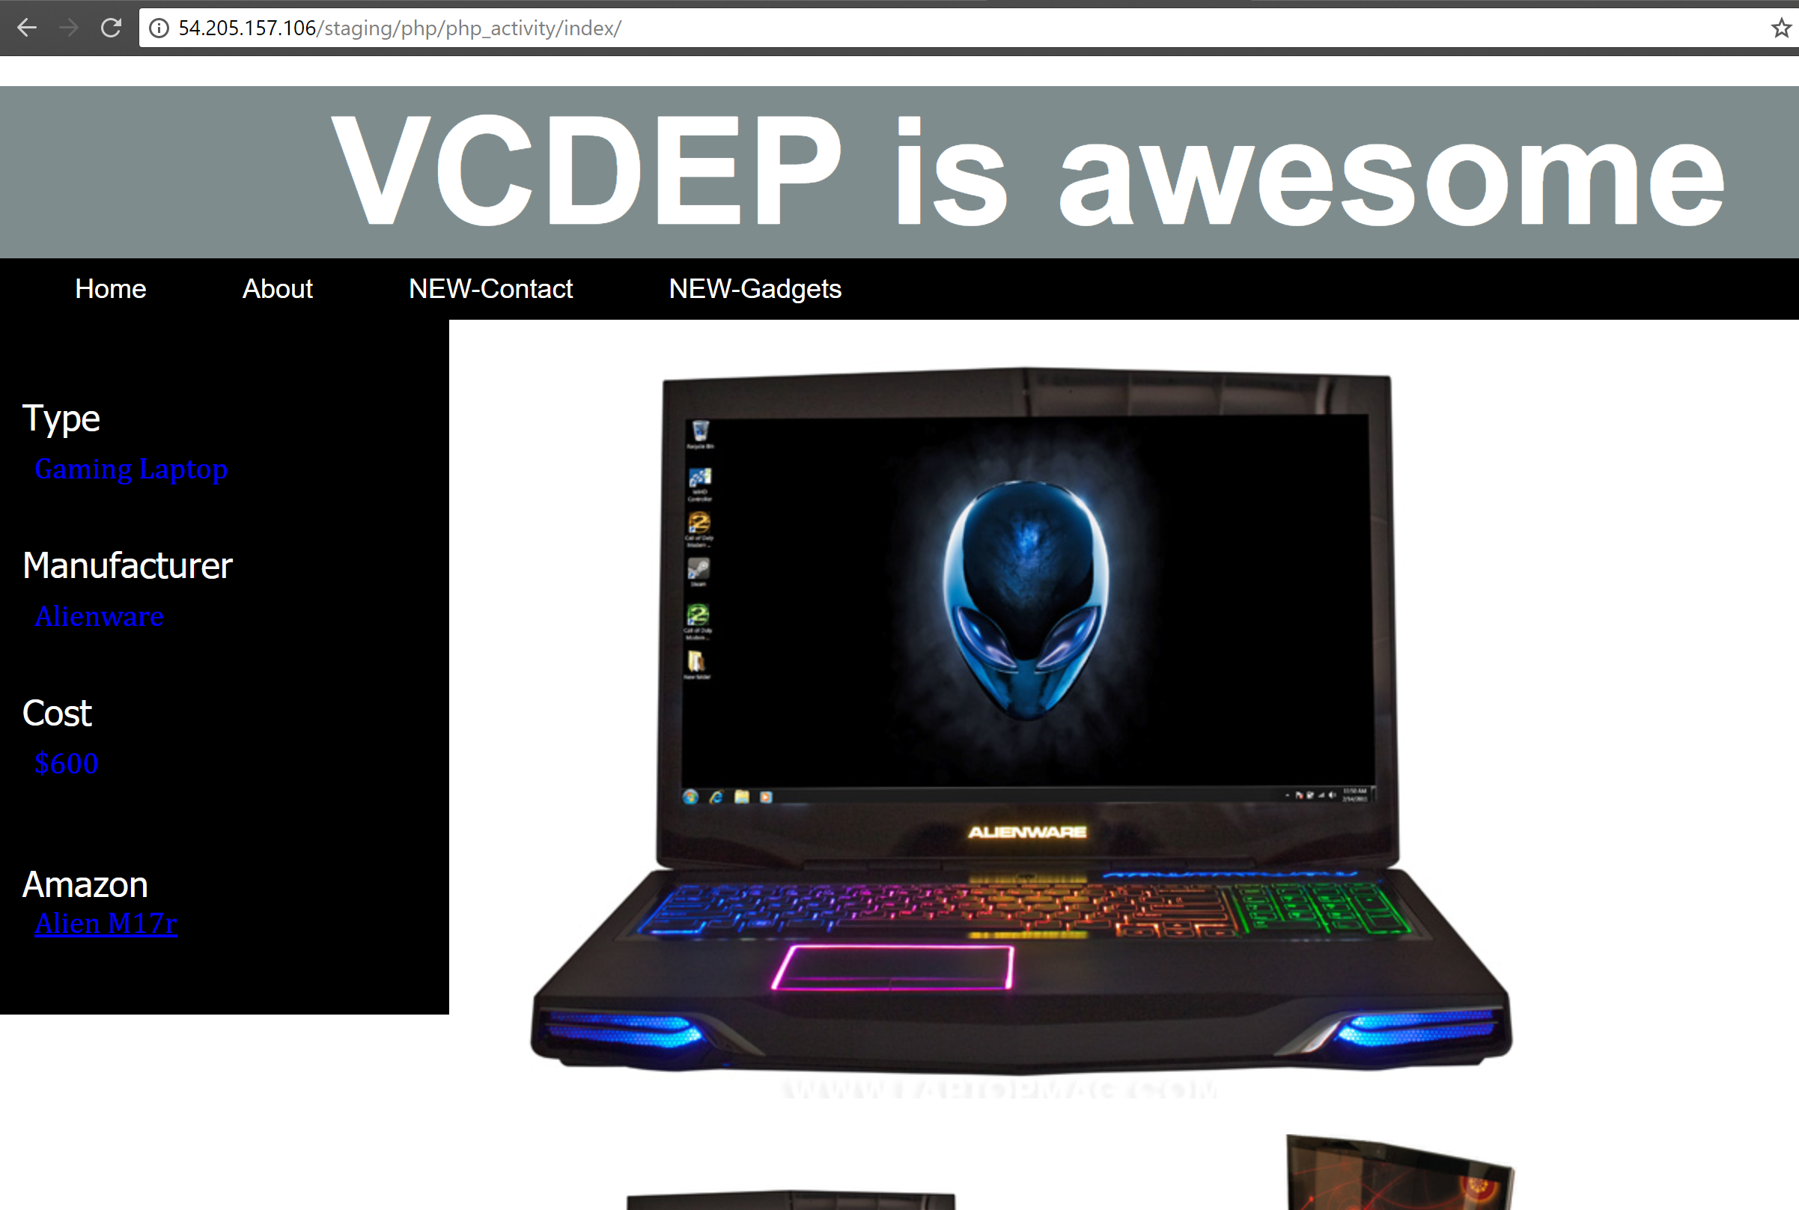

1. You should see something similar to this.

2)  **Failing a build:** In this section we will be failing a build so you can see what happens and what steps should be taken to discover why it failed and how to fix it.

**Re-Configuring the V-CDEP Application:**

1. Use the re-submit function built into the V-CDEP application by placing the stages in the same order as you did with the Configuration Scene and hit the Re-Submit button.

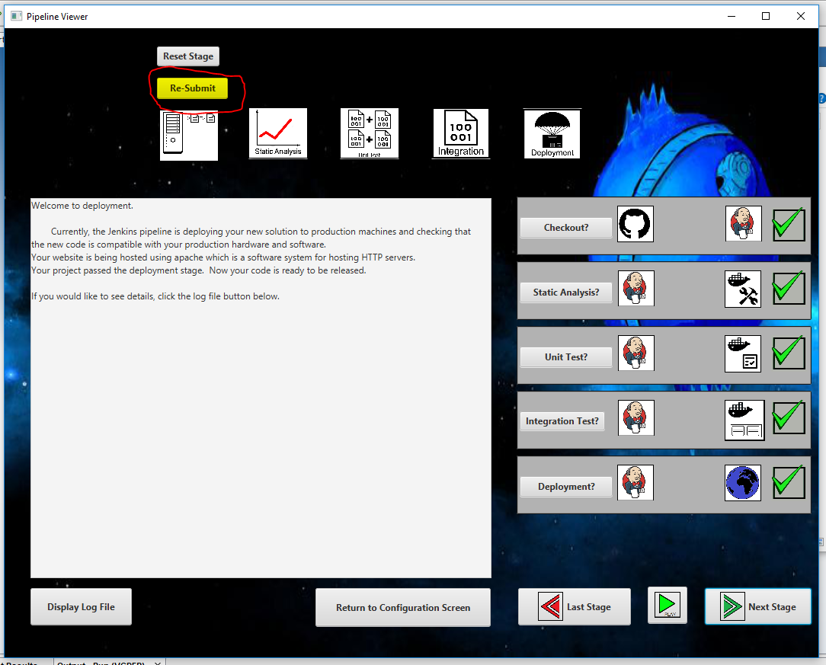

1. Then hit Re-Submit, which advances you to the Wait Scene.



**c) While waiting, continue on with the rest of the activity.**

**Creating a bug:** We will introduce a bug into our PHP project so we can see how the V-CDEP application reacts.

1. Navigate to the root directory of your git repository on your local machine and open the **“tests”** folder. This is where all of your tests are for both unit and integration.
2. Open up the **“Tester.php”** file in your favourite text editor.

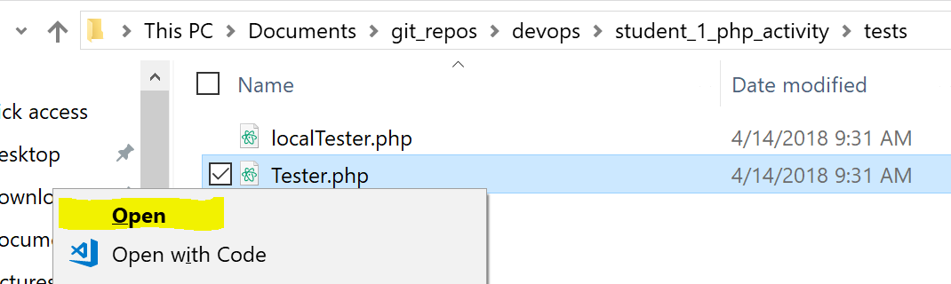

1. Edit the assertion for the **testName** test to test something other than “High-End Gaming Laptop” so that this test fails.

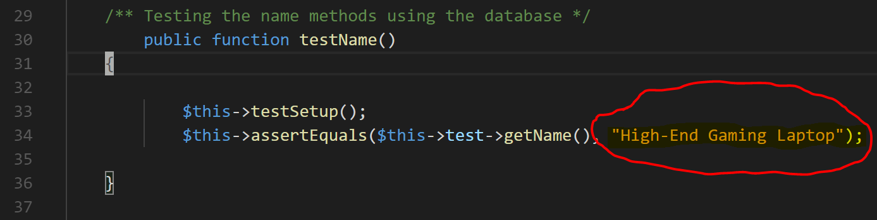

1. Save the changes, then open a terminal in the repository on your local machine (right-click in the folder in the file explorer) and perform the following commands:
2. **‘git add -A’** this will ensure that git saves all of the modifications made in the “Tester.php” file.
3. **‘git commit -m “<your_commit_message”’** this will commit all the changes with a message that represents what types of changes you did.
4. **‘git push origin feature’** this will push the changes from your local machine to the remote repository stored in GitHub. You will most likely have to input your user credentials for GitHub.
5. You should now see the V-CDEP application’s pipeline scene. Hit the **play** button and instead of seeing check marks on all the stages you should see the integration stage showing as failed.

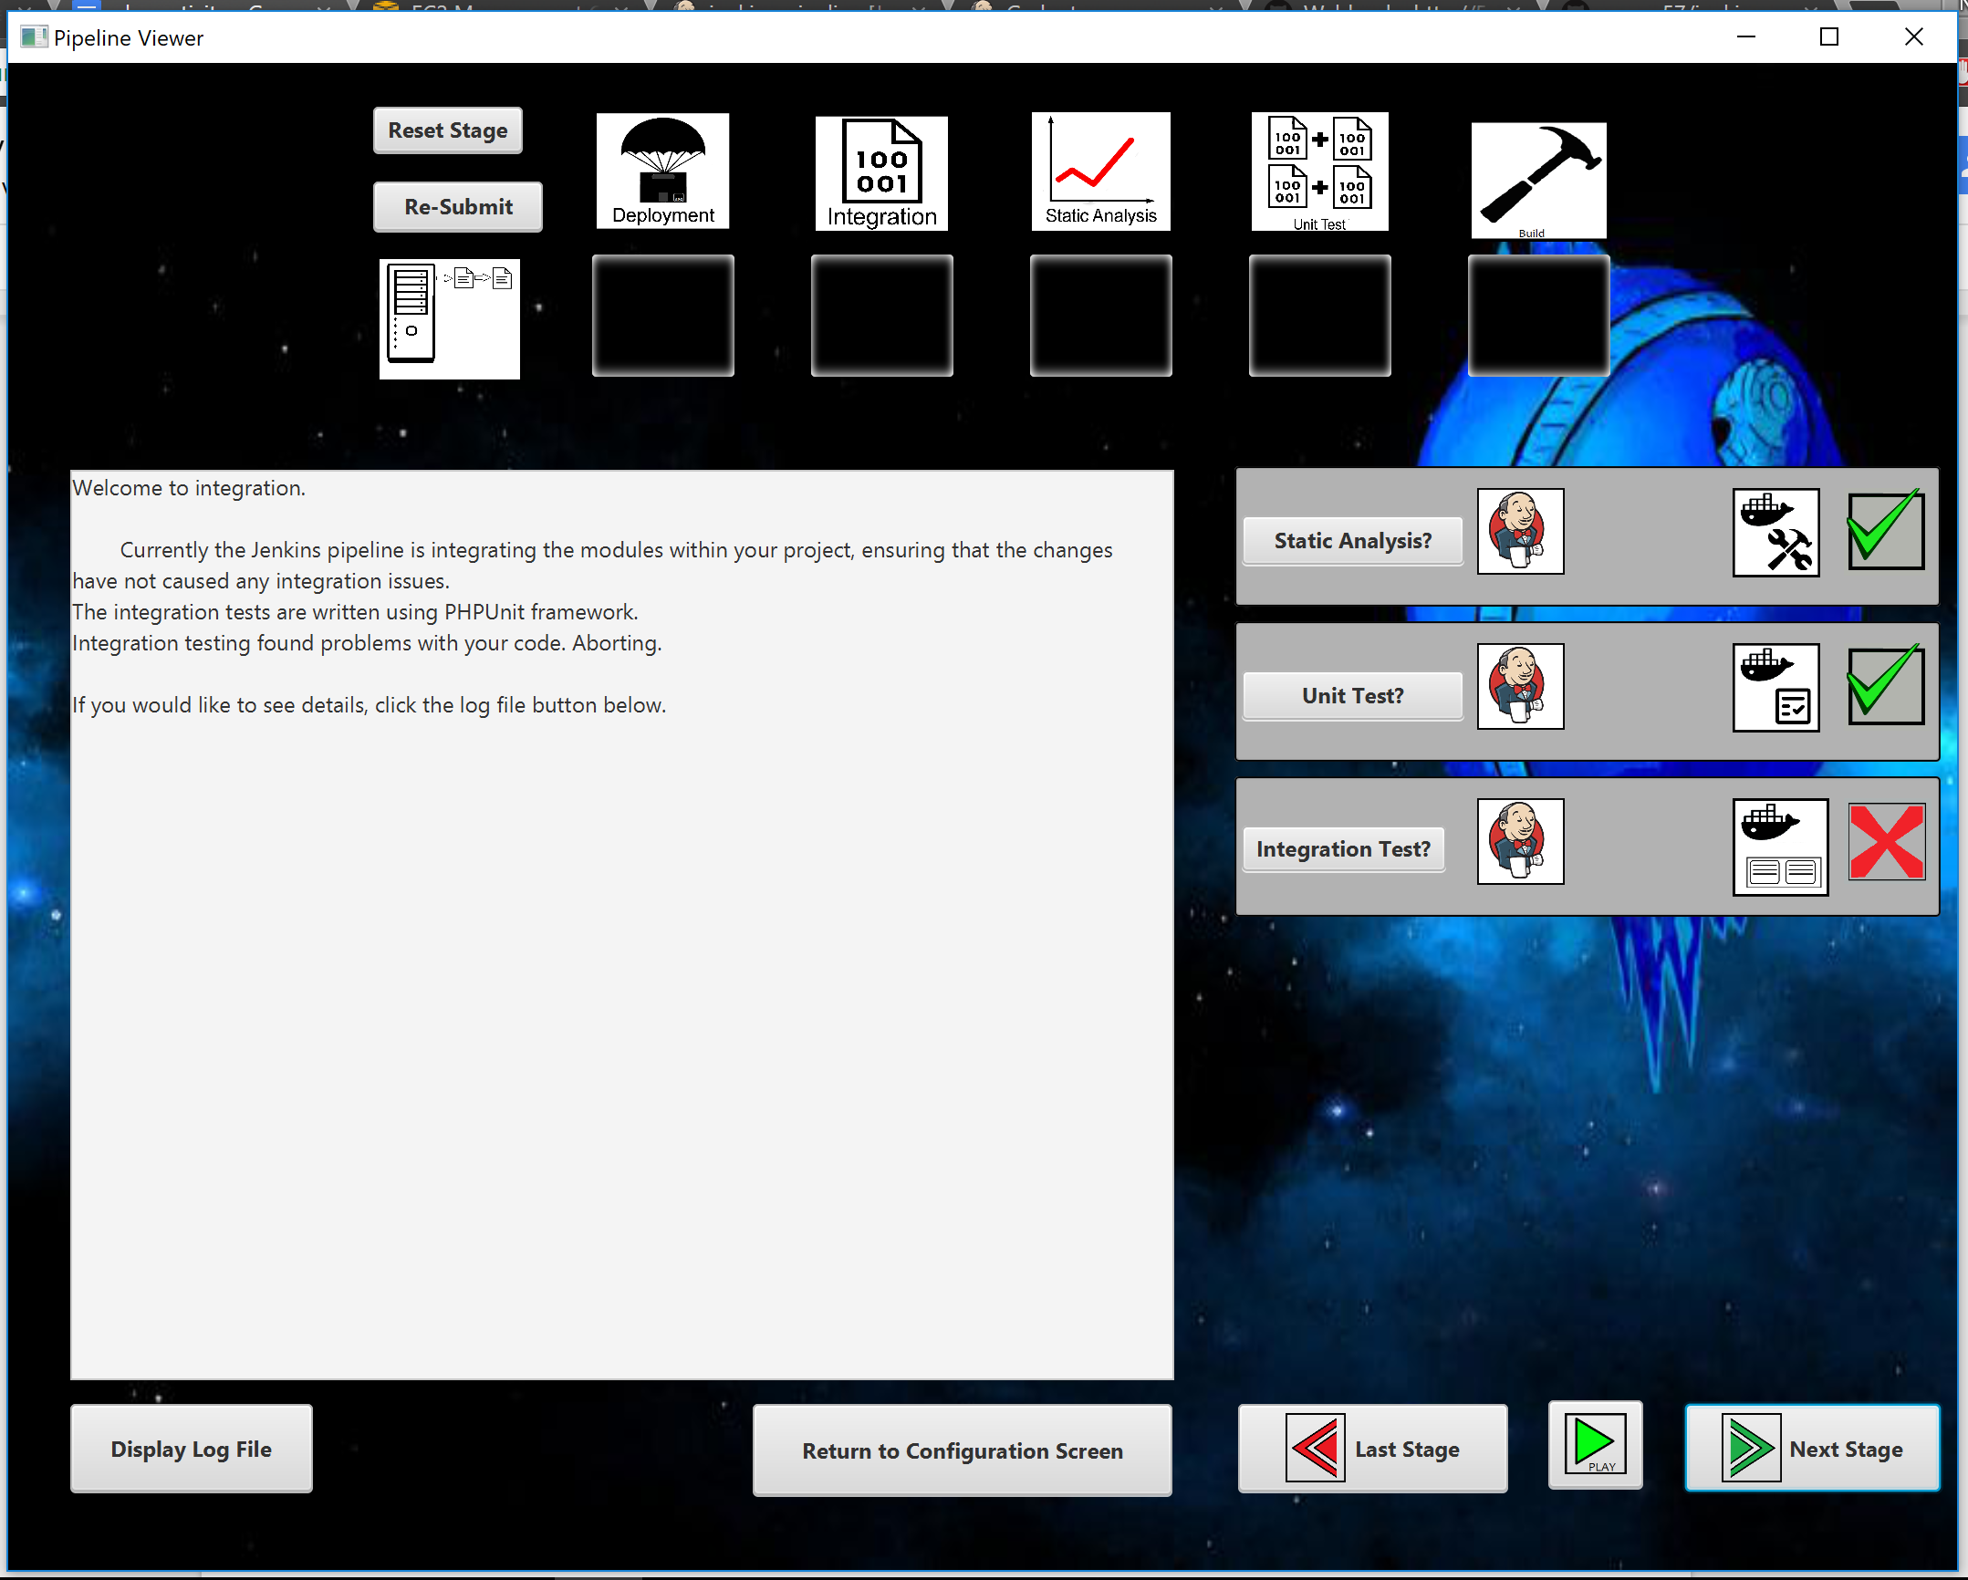

1. Open the Jenkins browser page and you should now see that the build has failed:

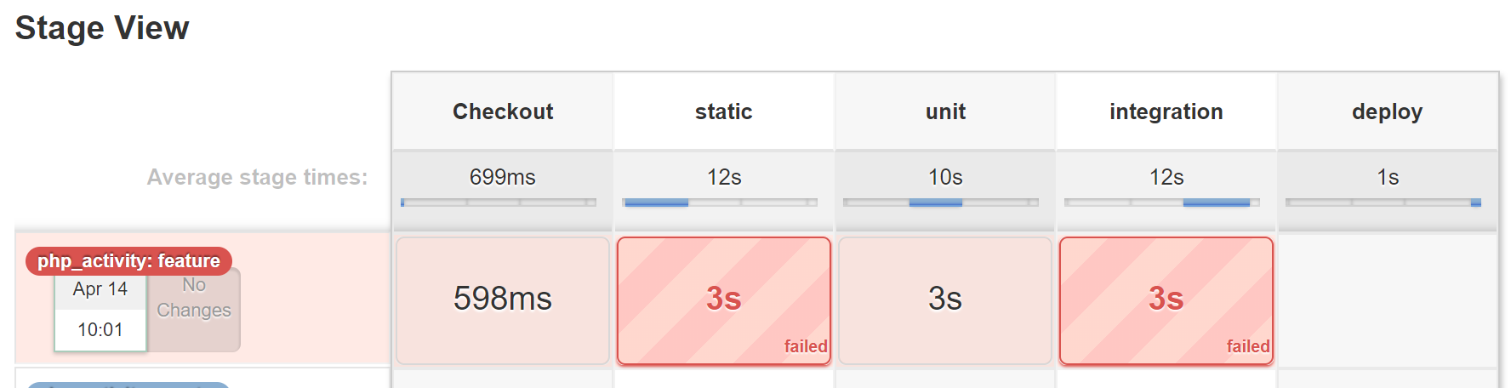

1. ***Before advancing:*** Make sure to to undo the bug you introduced by changing the testName assertion in the **“Tester.php”** file so that it matches “High-End Gaming Laptop” and then perform the same **git add, commit, and push** as discussed above.

***********************************************PART ONE COMPLETE*******************************

*************************************************PART TWO*******************************************

1. **Adding extra features:** In this section you will add a few extra functions and create some tests to see if the functions were created correctly.

**Configuring the V-CDEP Application:**

1. Navigate to where you downloaded the V-CDEP application or visit the [V-CDEP.com/download](http://vcdep.com/download) website and click the download button to download a fresh copy.



1. If you re-downloaded the V-CDEP application today you will need to extract it from the zip file.



1. This will extract the .jar file to the directory you specify.
2. Double click the V-CDEP.jar file to open it



1. Make sure the V-CDEP application is currently open and on the Configuration Viewer page.
2. Input the name of your repository in the first field. Example: If your repository is named “student_1_php_activity” you would input **“student_1_php_activity”** into that field.
3. For the branch you must use **“feature”**.
4. For the Jenkin’s server you must place the **Jenkins_ip_address** given by your professor.
5. To fill in the Local Git Repository field click the browse button.



1. This will open the File Directory.. Navigate to where your git repository is stored on your machine and then hit the **“Select Folder”** button.



1. Select **PHP** as your language from the list of choices in the combobox.
2. Your Configuration Viewer should look similar to the following



1. Now that you have completed configuration you will select your stages using the drag and drop functionality built into the V-CDEP application.
2. The stages you **must select** ***for this activity*** are “Static Analysis, Unit Test, Integration, and Deployment” ***in that order.*** Shuffling this order is allowed, but for the purposes of this activity (and its time constraints) please use this ordering.



1. This is what your Stage Configuration section should look like.
2. Once you have performed the previous steps, hit the submit button!





1. If everything was inputted correctly and prerequisites were met, you should see the Wait Scene.

**Adding the functions:**

1. Navigate to the root directory for your git repository on your local machine and open the **index director.** This is where all of the PHP files are located for the application.
2. Open the **“Gadget.php”** file in your favourite text editor and implement the **“getCost”** and **“getManufacturer”** functions similar to the other accessor functions in the class **Gadget.**

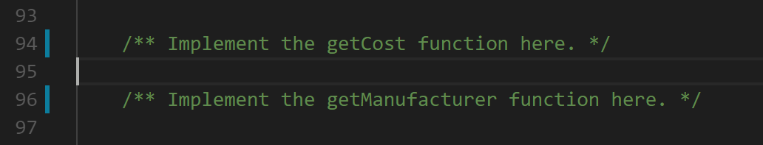

1. Once finished, ***make sure to save the file.***
2. Navigate to the tests folder and open the **“Tester.php”**.
3. Implement the **“testCost”** and **“testManufacturer”** functions to assert that the **“getCost”** and **“getManufacturer”** functions return the string **“$1300”** and string **“Alienware”**, respectively. Refer to the other test functions in the “Tester.php” for help.
4. These tests are Unit tests, in that they test a single responsibility function, in isolation from the other functions.

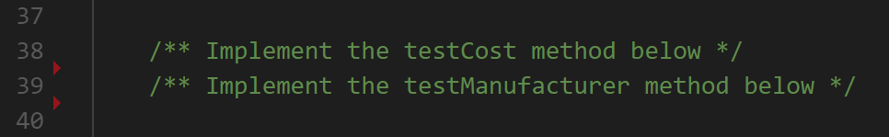

1. Make sure to **save** the file when you are finished
2. Navigate back to the root directory of the git repository and open the **“index.php”** file.
3. Edit the left sidebar so that it displays information about the manufacturer and cost of the gadget being displayed.

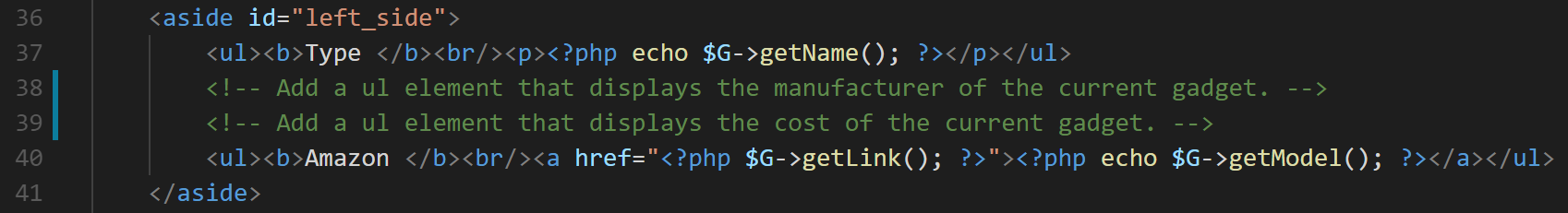

1. Save the changes, then open a terminal in the repository on your local machine (right-click in the folder in the file explorer) and perform the following commands:
2. **‘git add -A’** this will ensure that git saves all of the modifications made in the “Tester.php” file.
3. **‘git commit -m “<your_commit_message”’** this will commit all the changes with a message that represents what types of changes you did.
4. **‘git push origin feature’** this will push the changes from your local machine to the remote repository stored in GitHub. You will most likely have to input your user credentials for GitHub.

**Viewing the changes:** This section will have you view all the changes made to make sure everything went smoothly.

1. Open the V-CDEP application, which should now be on the pipeline scene, and run through the animations again by pressing the **“play”** button.
2. Once it has finished, go to the browser where the website page is up and reload the page to see the changes.
3. ***If the pipeline showed a failure or you do not see the changes on your website please contact your instructor or one of the assistants***.

*********************************************PART TWO COMPLETE************************************